Kafka

1) Ejercicio 1: Operaciones básicas

> cd /usr/hdp/current/kafka-broker

> bin/kafka-server-start.sh config/server.properties

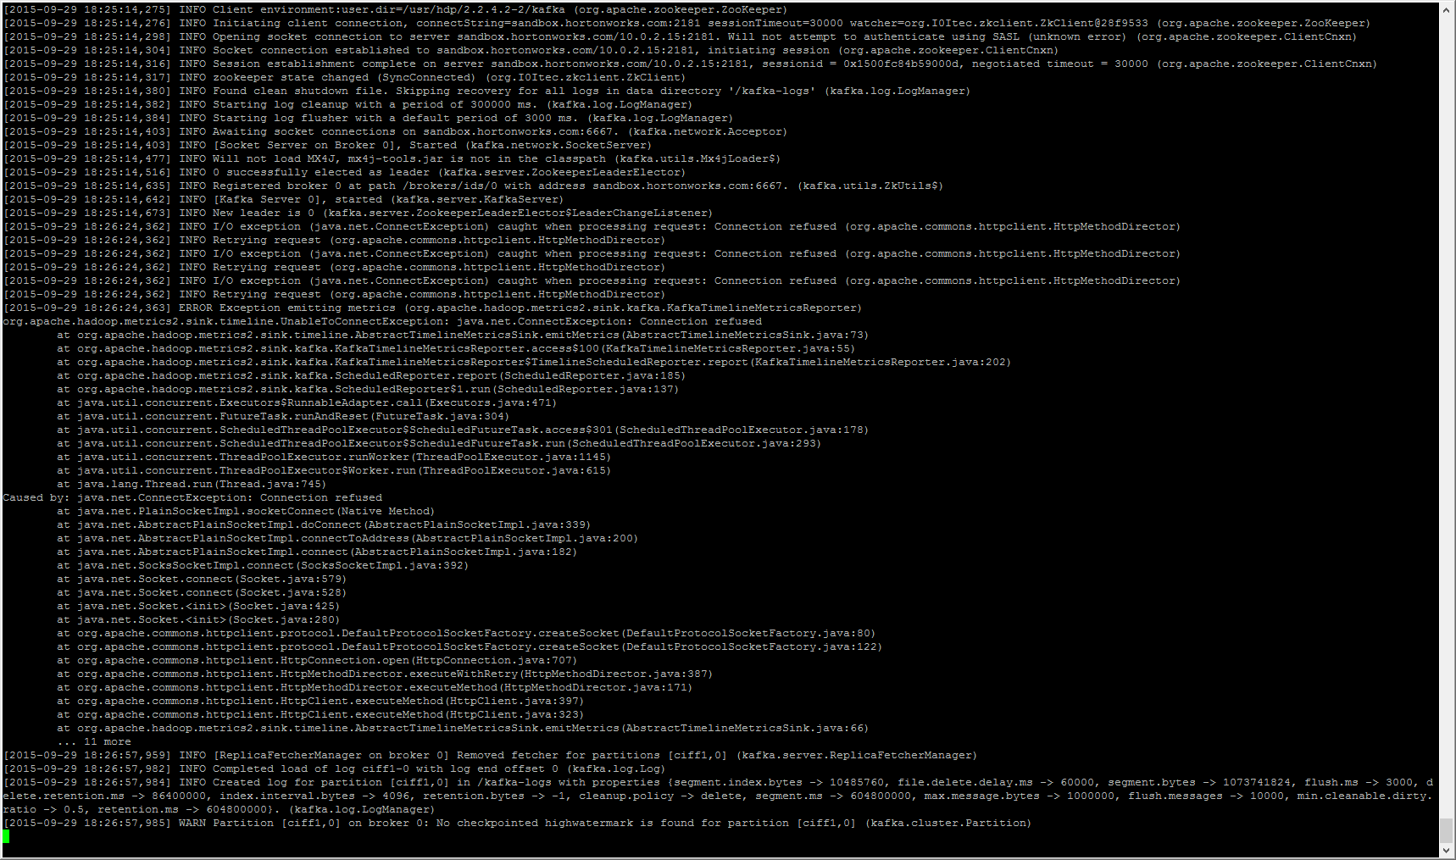

> /usr/hdp/current/kafka-broker/bin/kafka-topics.sh --zookeeper localhost:2181 --create --replication 1 --partition 1 --topic ciff1

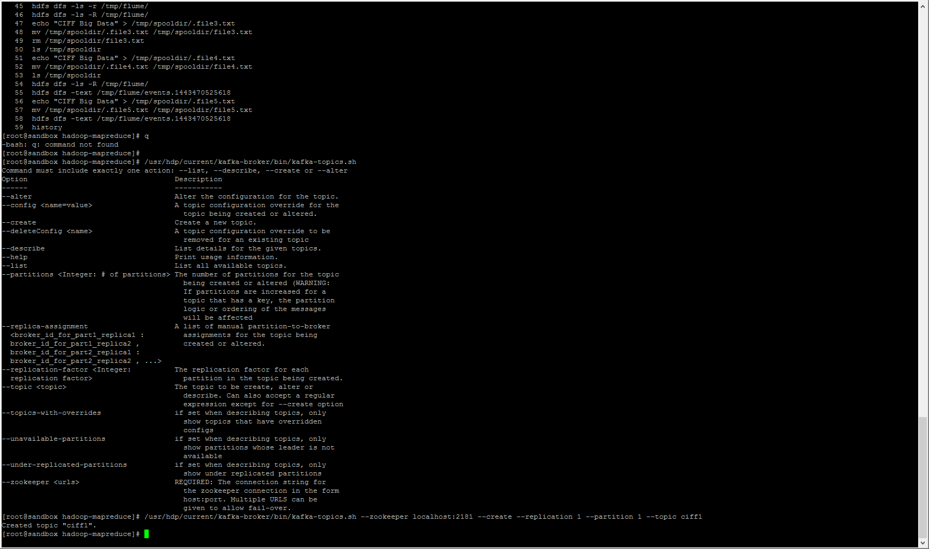

> /usr/hdp/current/kafka-broker/bin/kafka-topics.sh --zookeeper localhost:2181 --list

> /usr/hdp/current/kafka-broker/bin/kafka-topics.sh --zookeeper localhost:2181 --describe

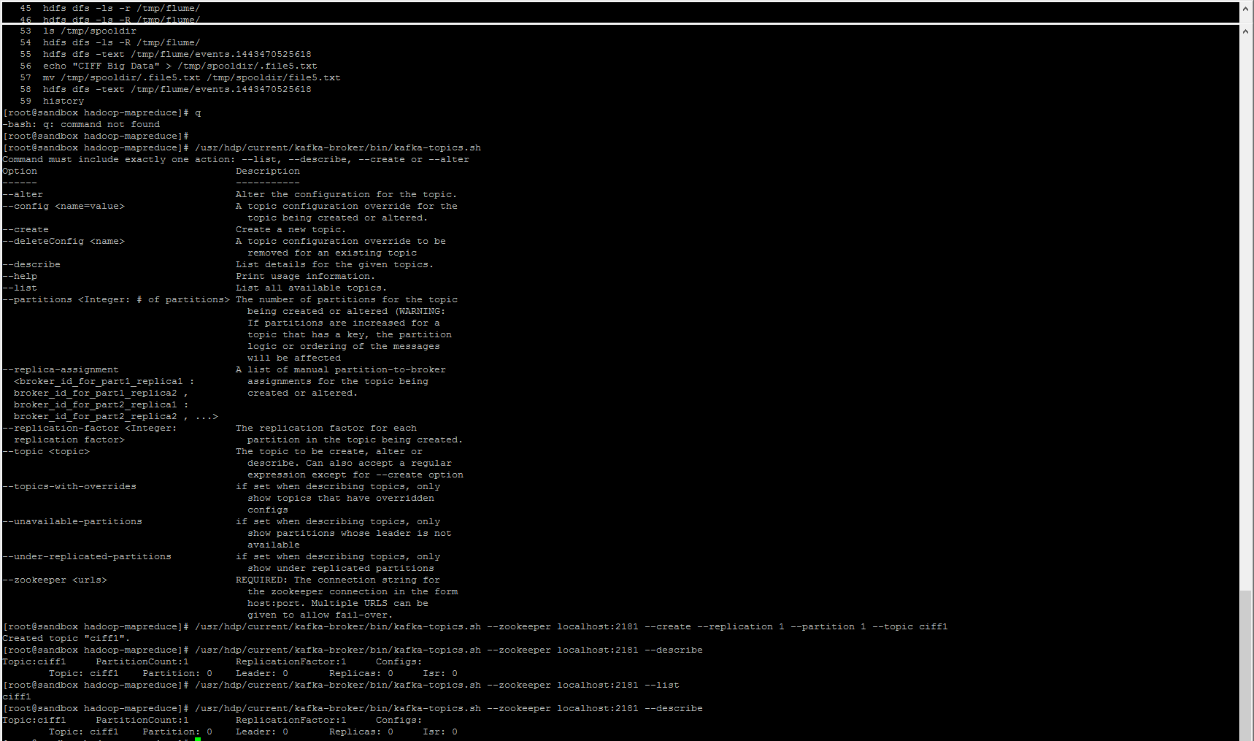

> /usr/hdp/current/kafka-broker/bin/kafka-console-producer.sh --topic ciff1 --broker-list sandbox.hortonworks.com:6667

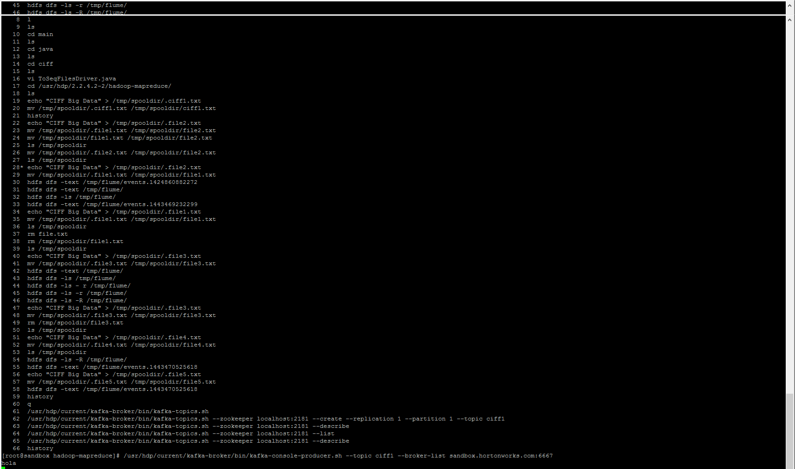

> /usr/hdp/current/kafka-broker/bin/kafka-console-consumer.sh --zookeeper localhost:2181 --topic ciff1



> /usr/hdp/current/kafka-broker/bin/kafka-console-consumer.sh --zookeeper localhost:2181 --topic ciff1 --from-beginning

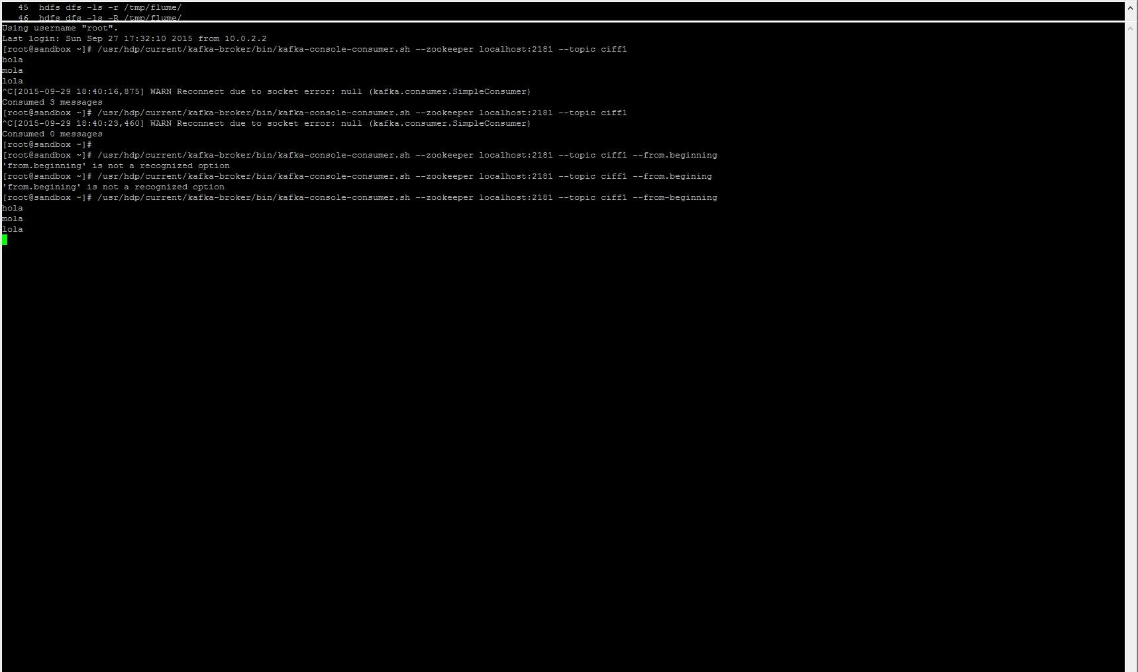

2) Ejercicio 2: Cluster de varios brokers

> bin/kafka-server-start.sh config/server.properties

> bin/kafka-server-start.sh config/server-2.properties

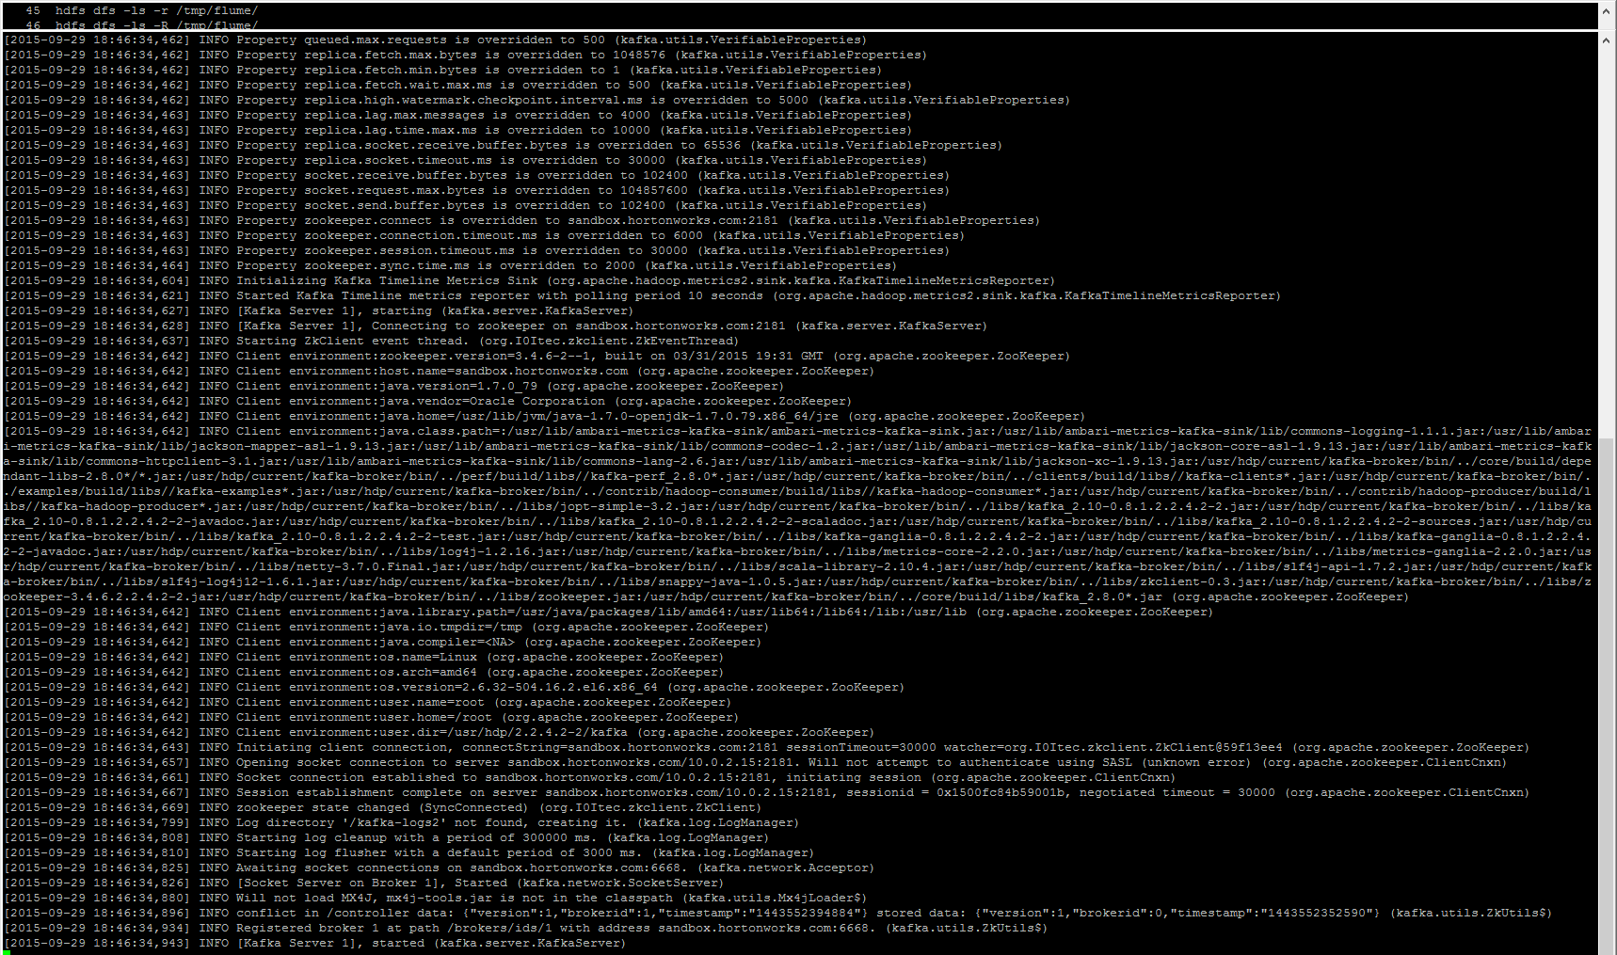

> /usr/hdp/current/kafka-broker/bin/kafka-topics.sh --zookeeper localhost:2181 --create --replication 2 --partition 2 --topic ciff2

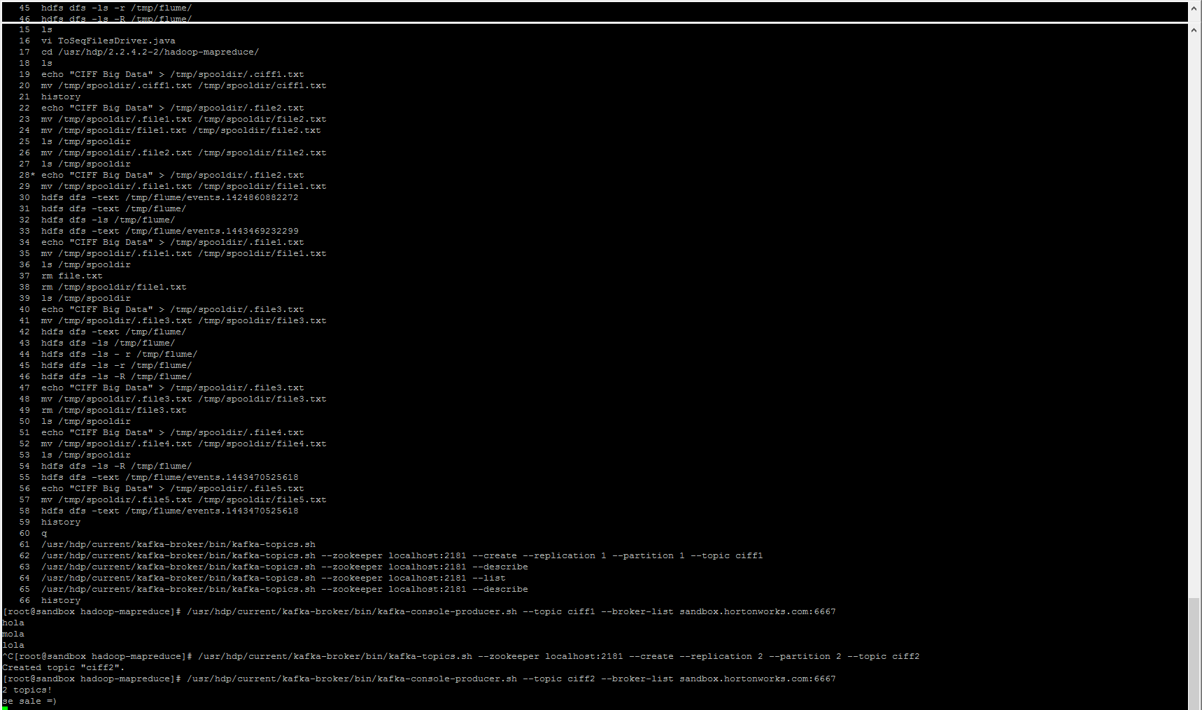

> bin/kafka-topics.sh --describe -zookeeper localhost:2181

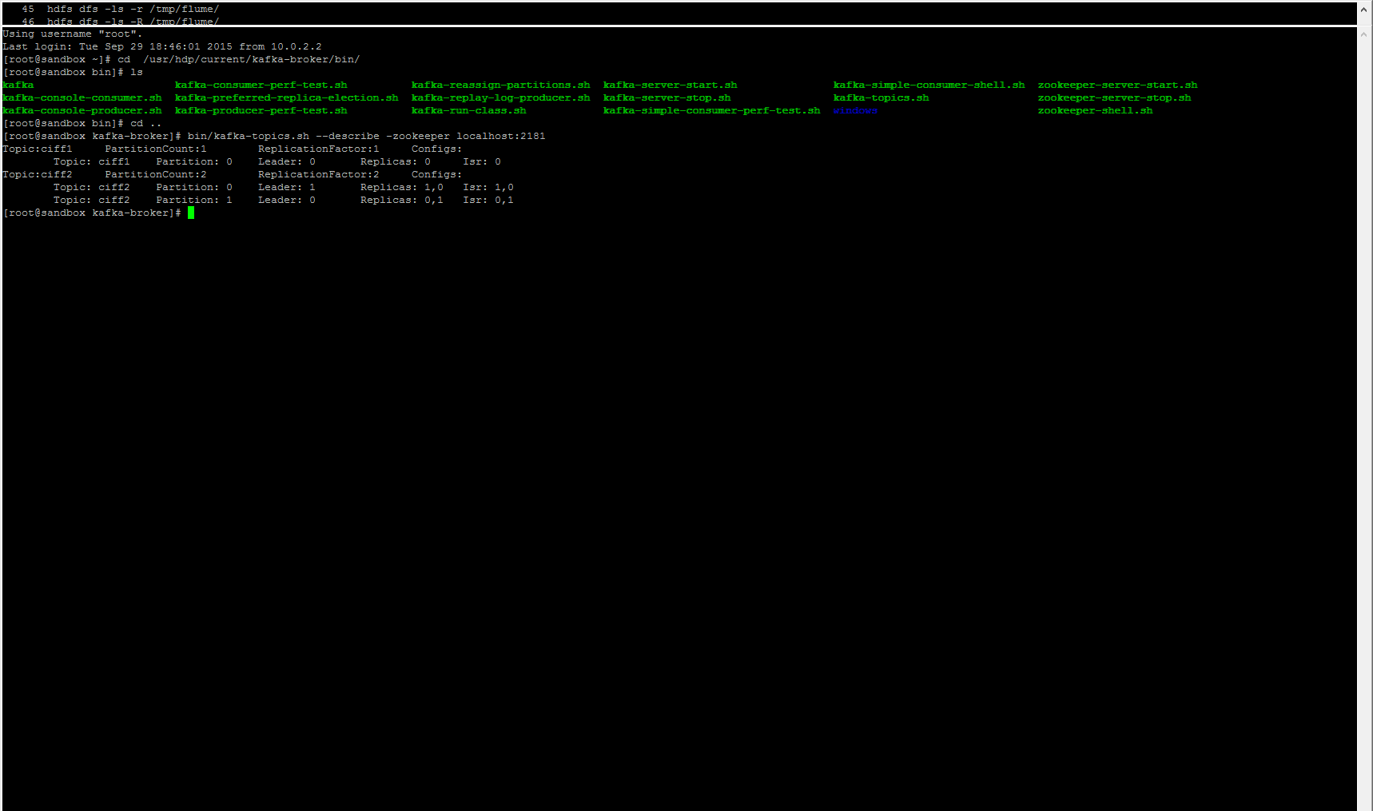

3) Ejercicio 3: Tolerancia a Fallos

> Ctrl + Z

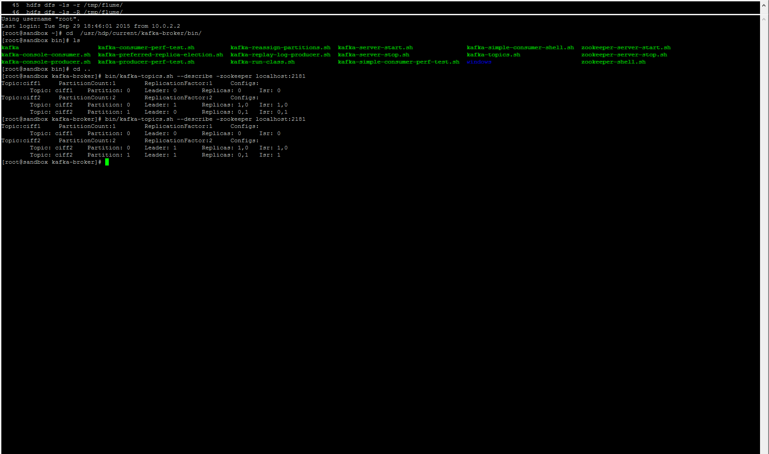

> /usr/hdp/current/kafka-broker/bin/kafka-console-consumer.sh --zookeeper localhost:2181 --topic ciff2 --from-beginning

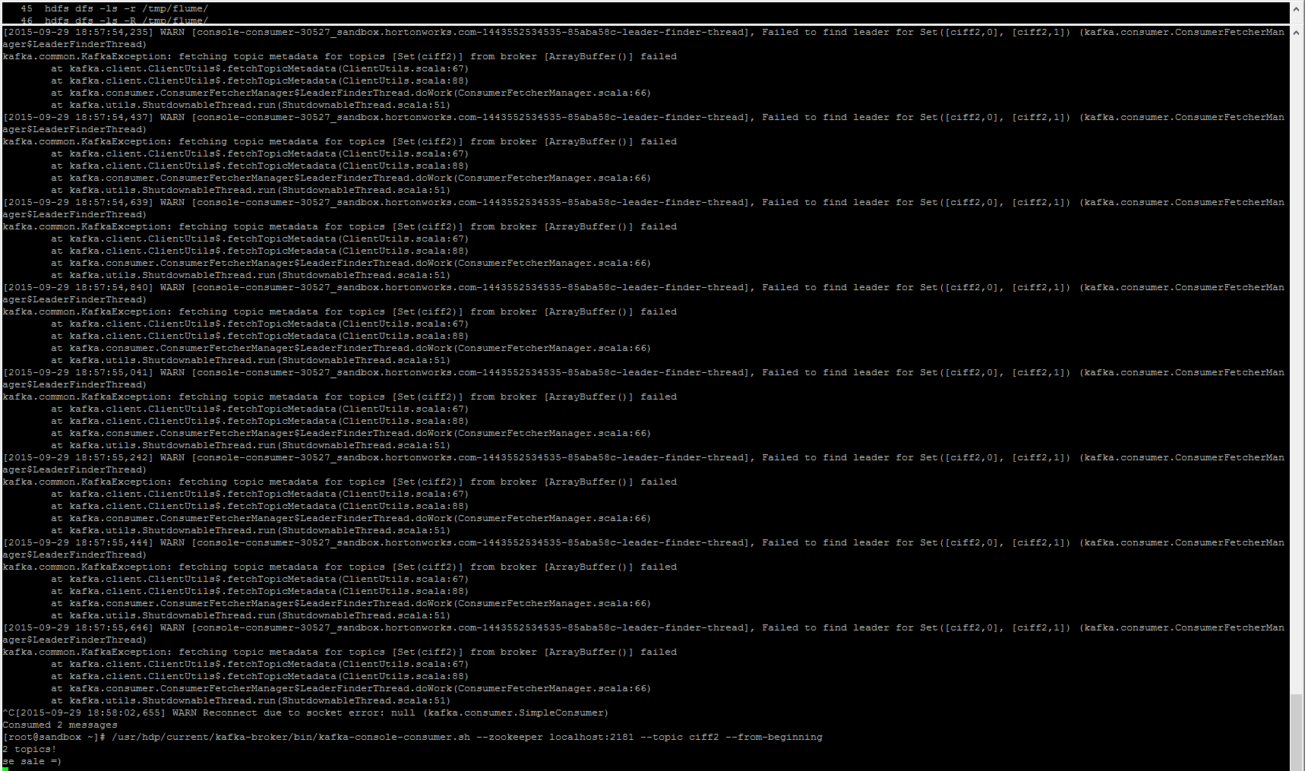

4) Ejercicio 4: Ingesta de eventos Flume en Kafka

> mvn clean install -DskipTests

> cd flume-ng-kafka-sink-master/dist/target

> unzip flume-kafka-sink-dist-0.5.0-bin.zip

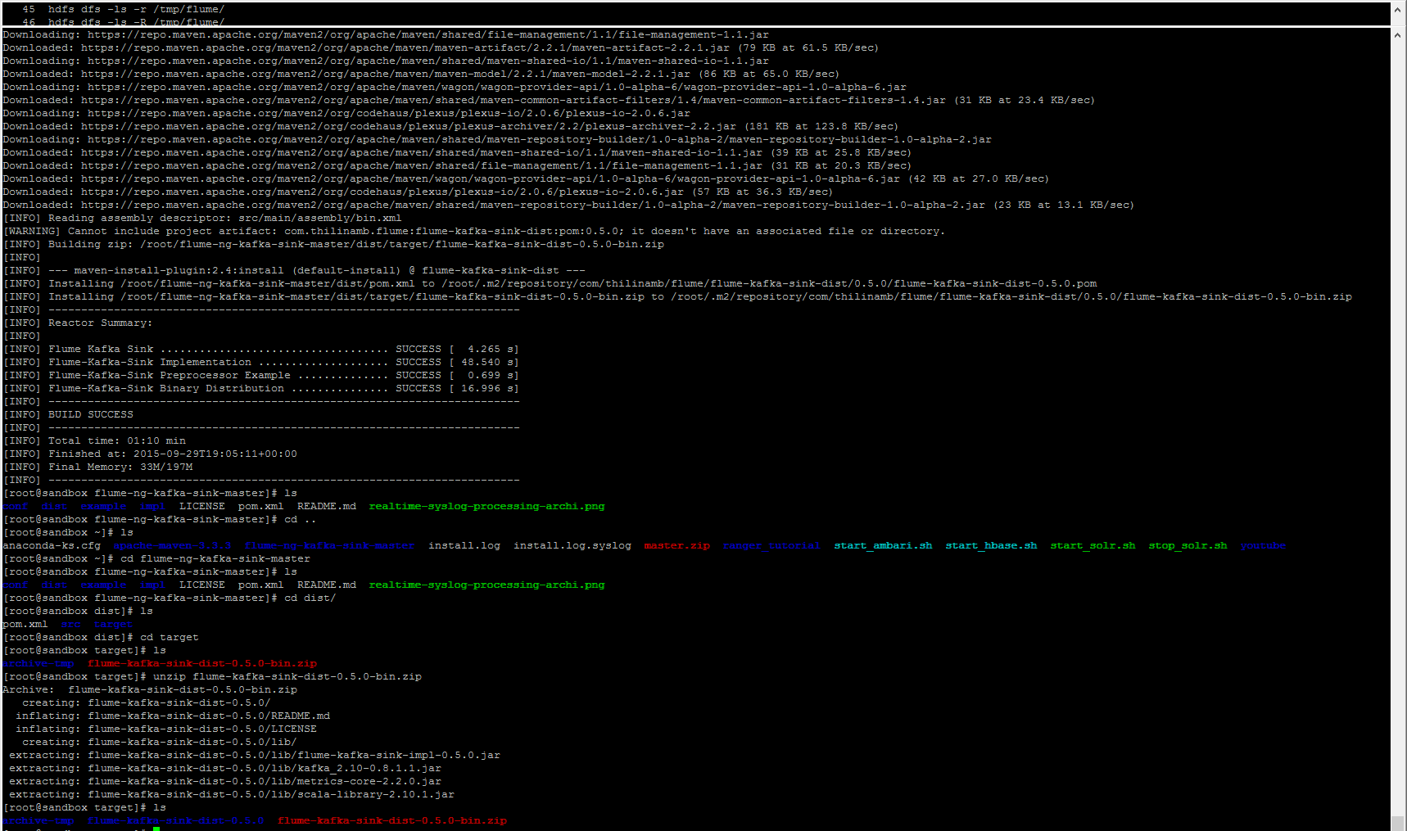

> cd flume-kafka-sink-dist-0.5.0

> cp \* /usr/hdp/current/flume-server/lib/

> vi spool-to-kafka.properties

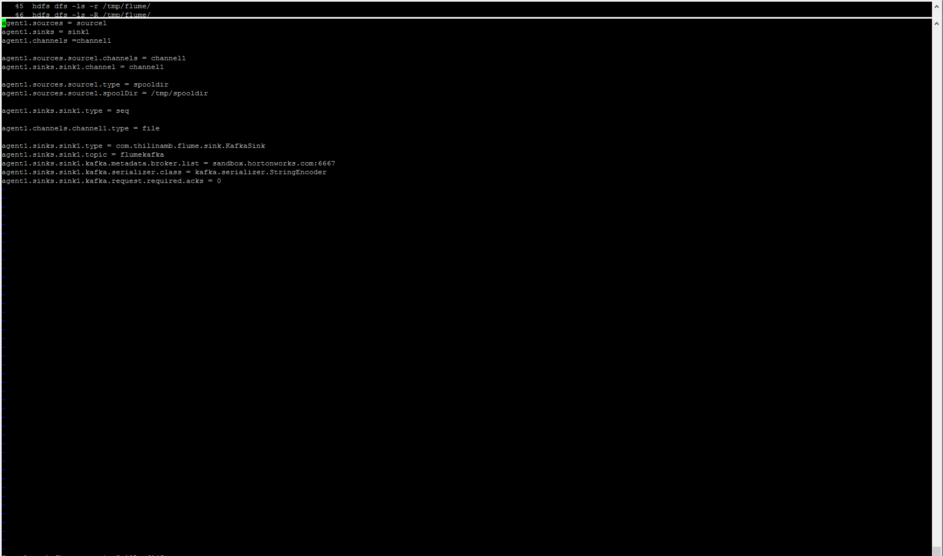

> flume-ng agent --conf-file /etc/flume/conf/spool-to-kafka.properties --name agent1 --conf /etc/flume/conf/ -Dflume.root.logger=INFO,console

> bin/kafka-topics.sh --describe -zookeeper localhost:2181